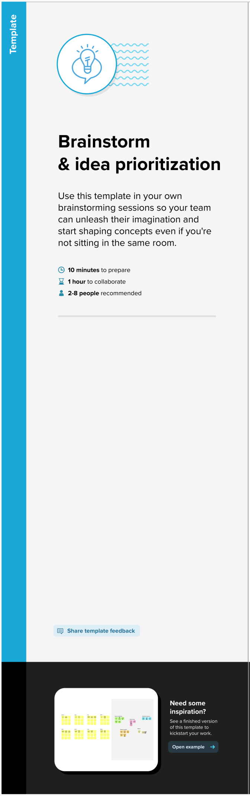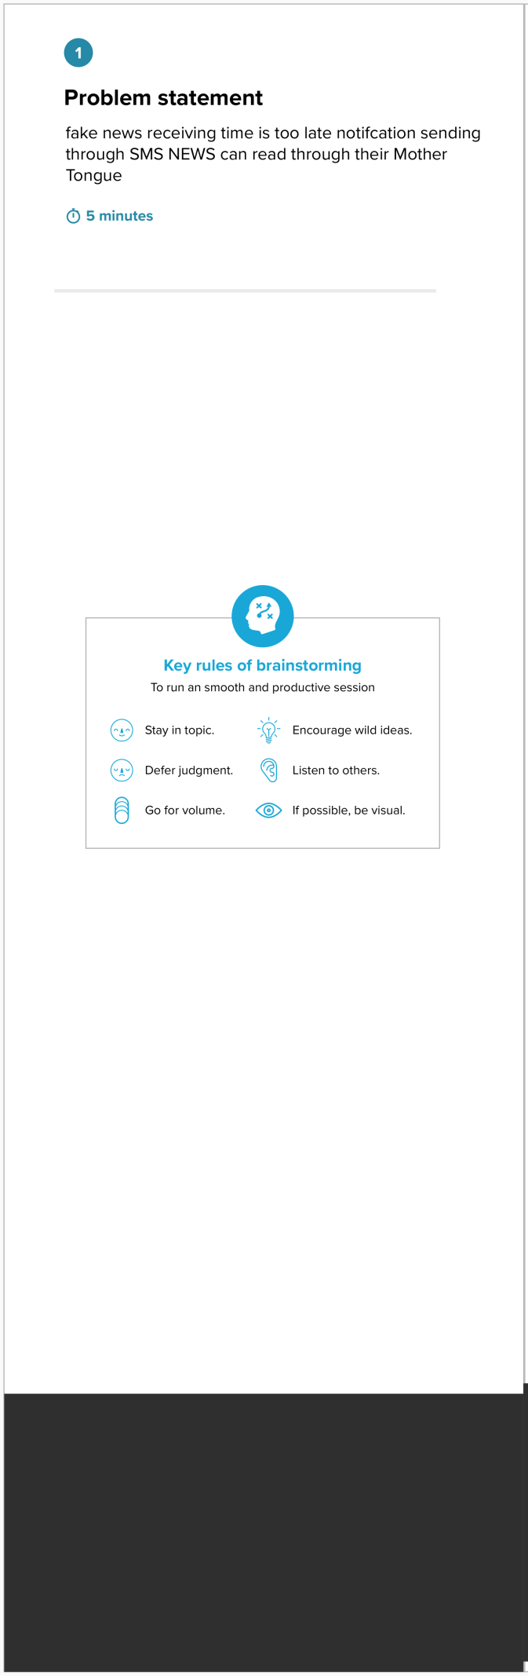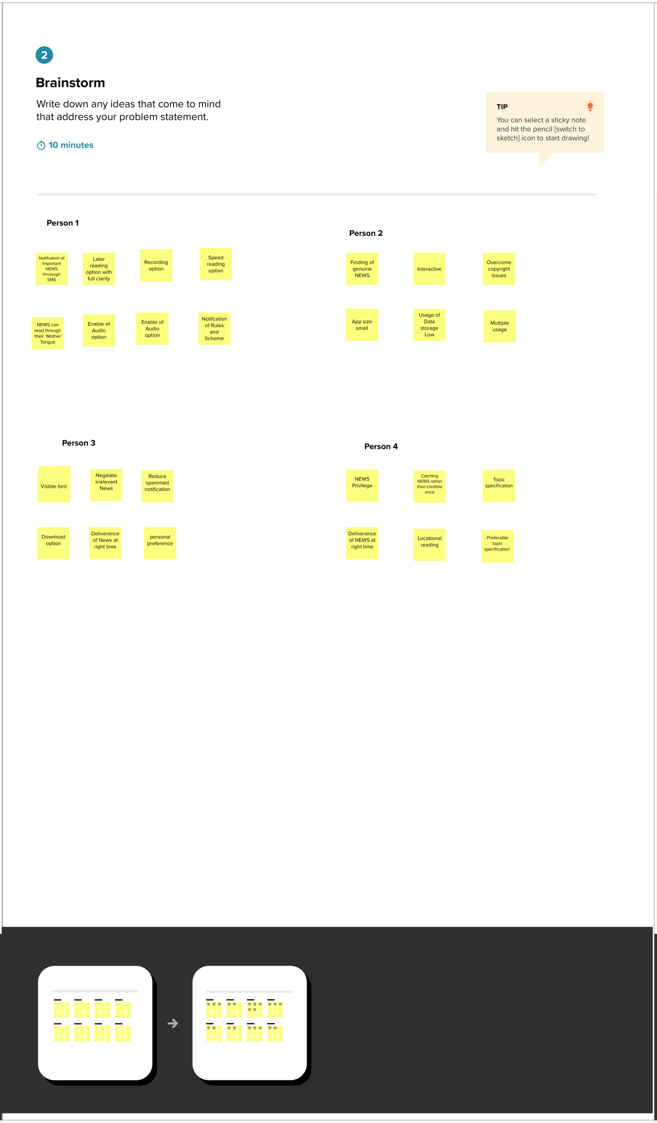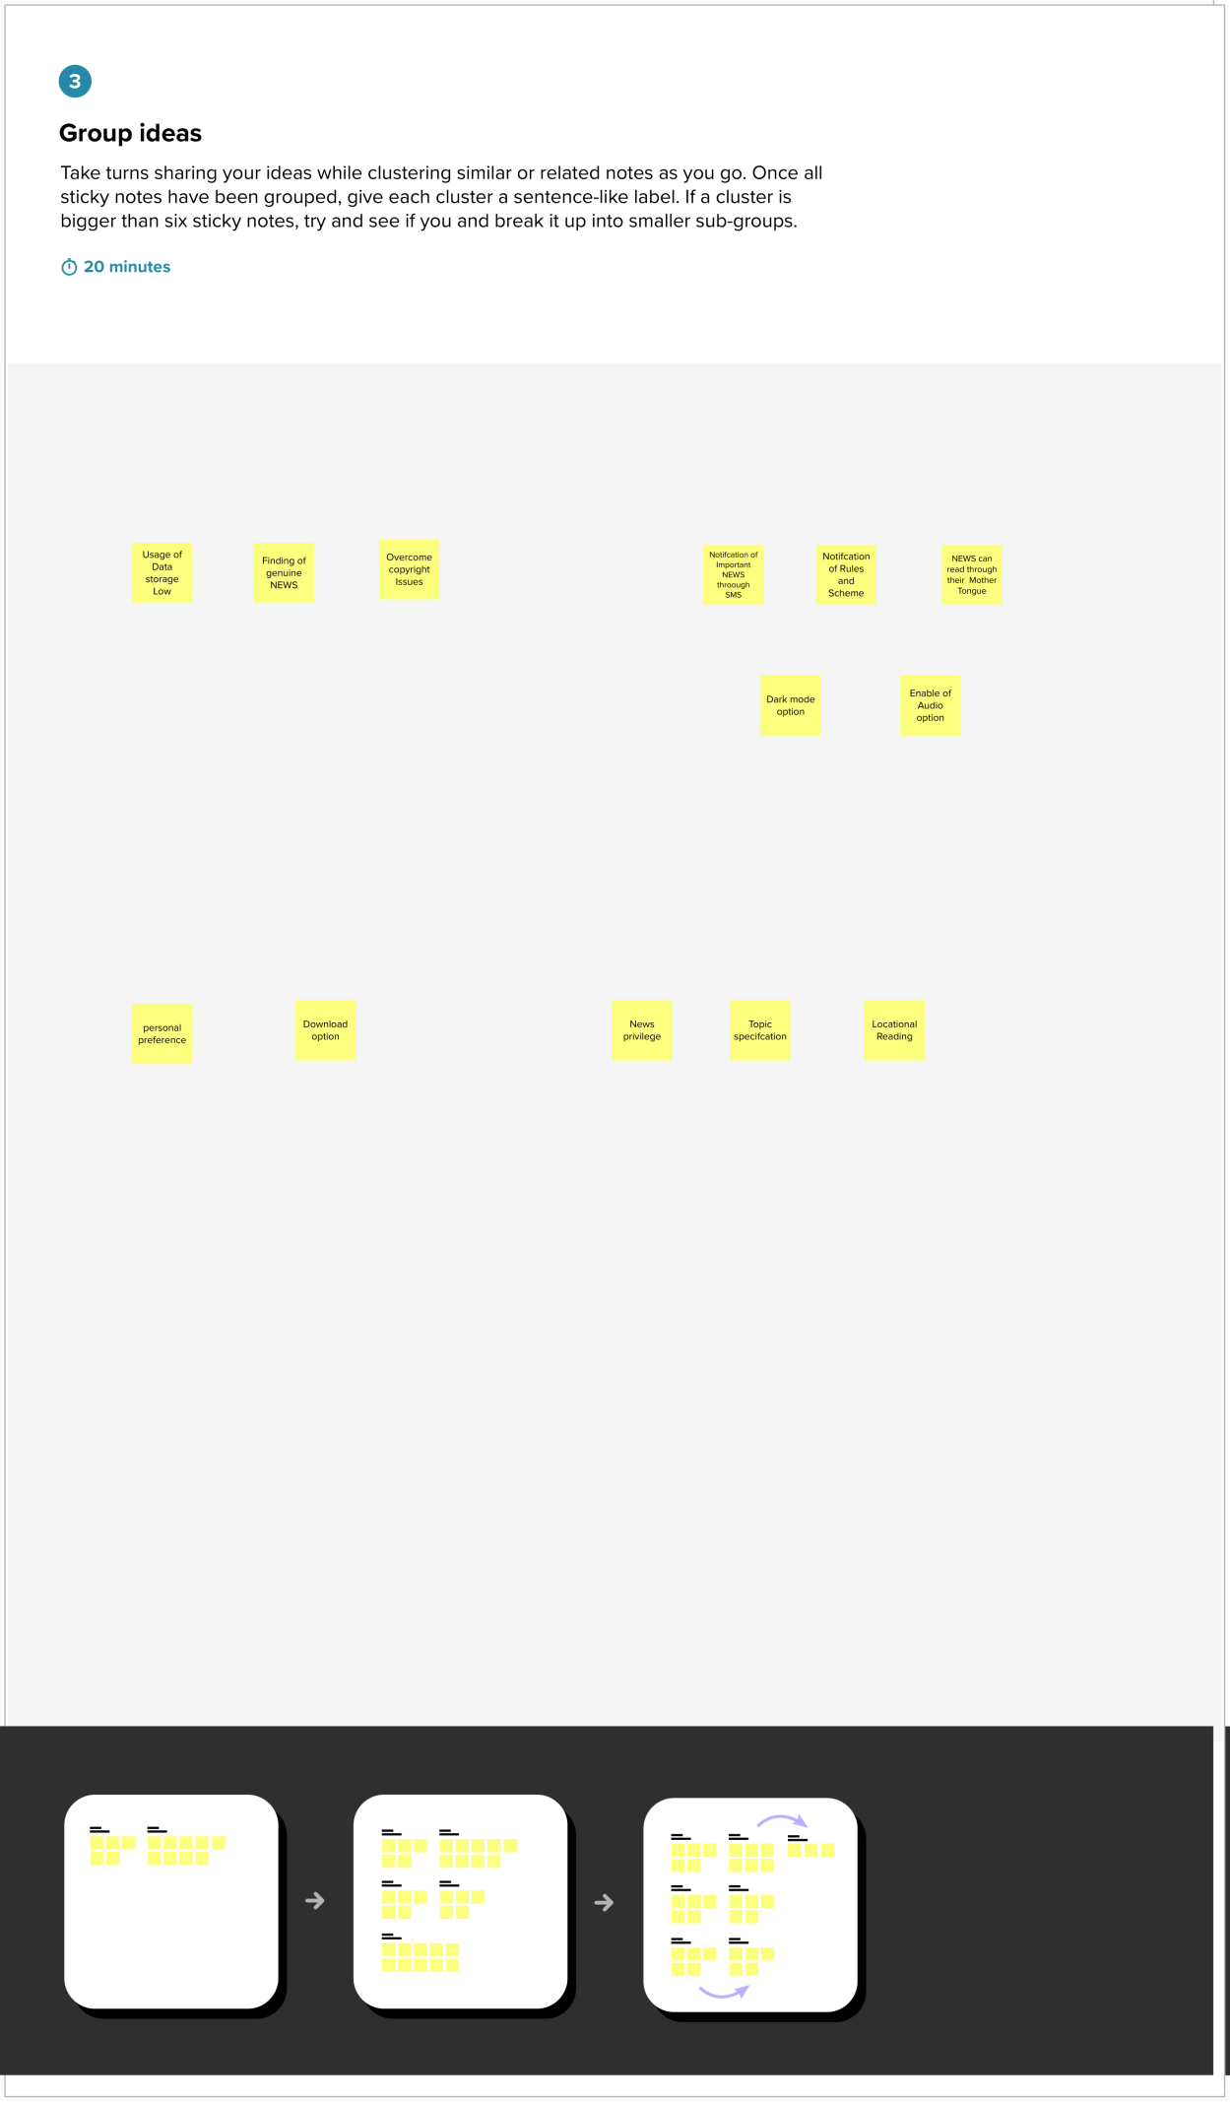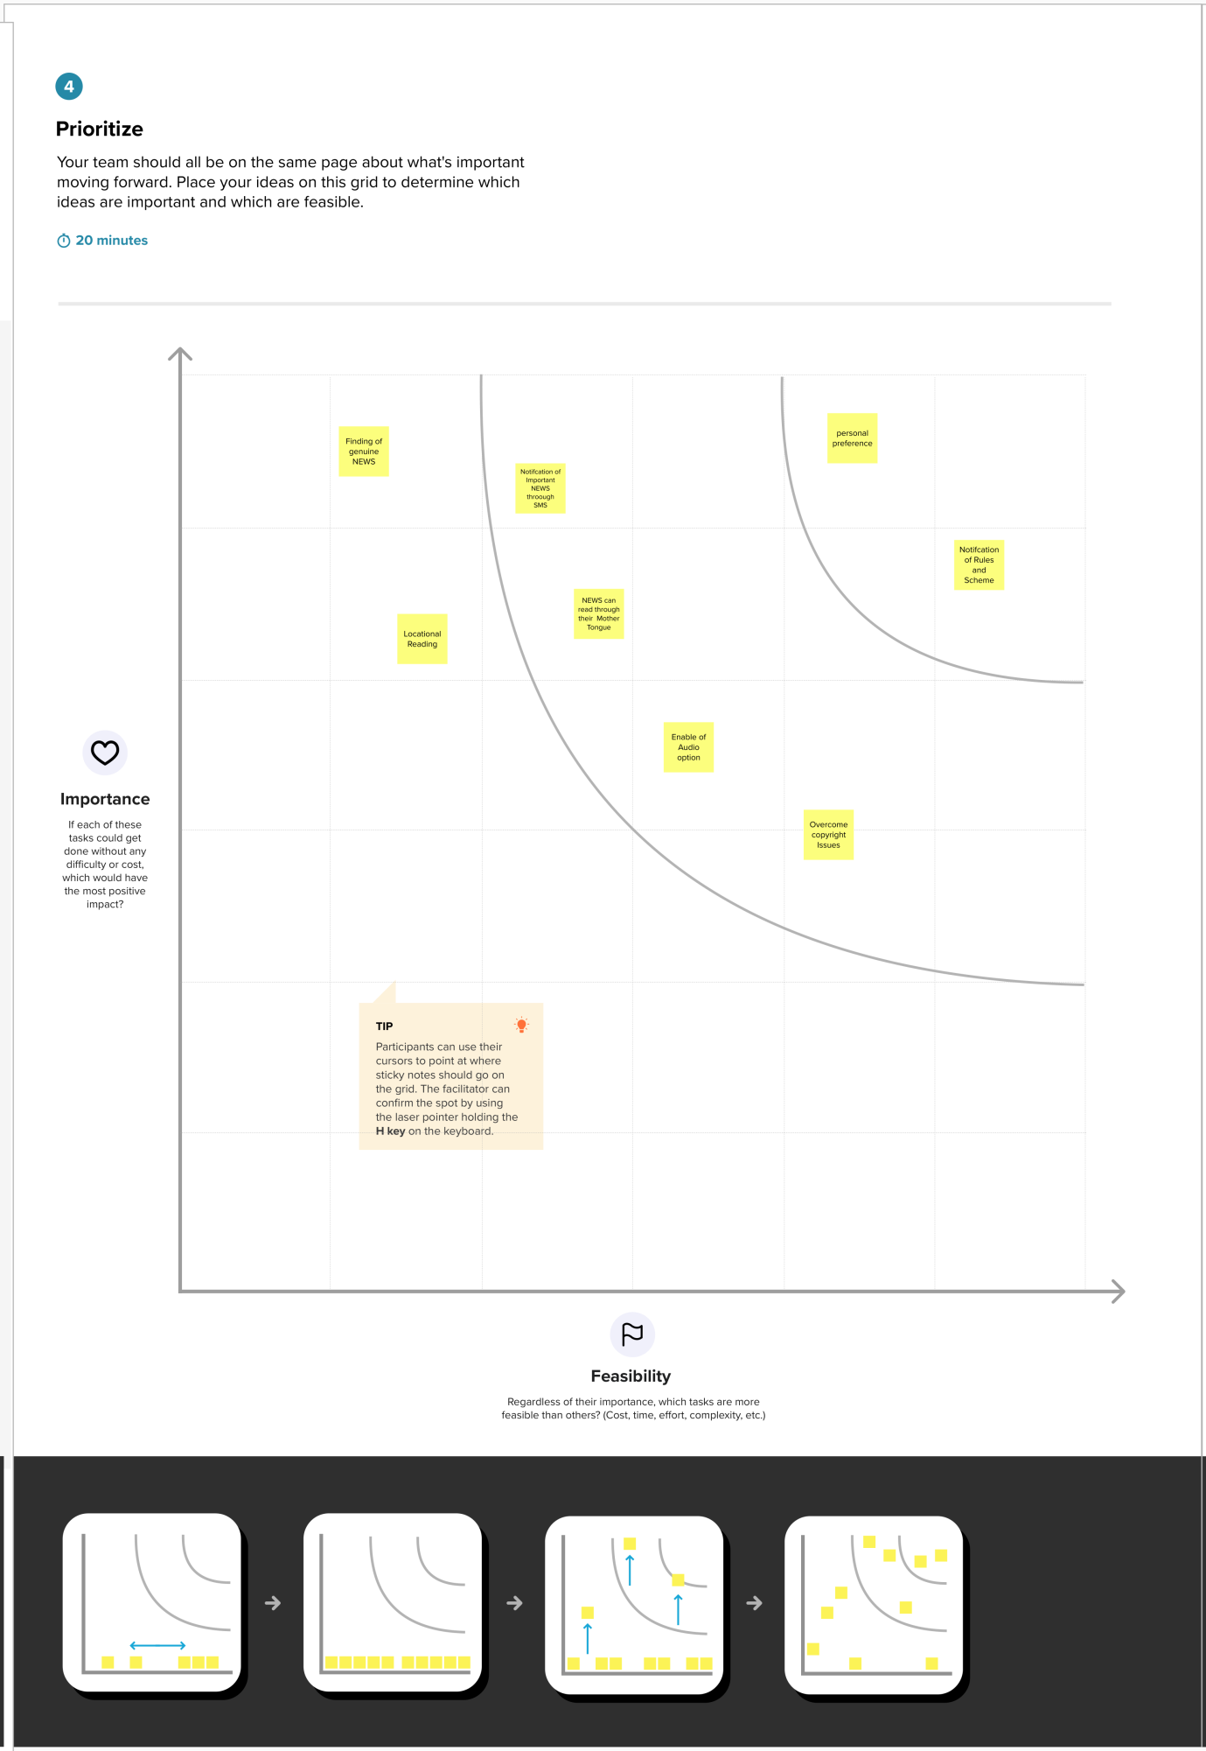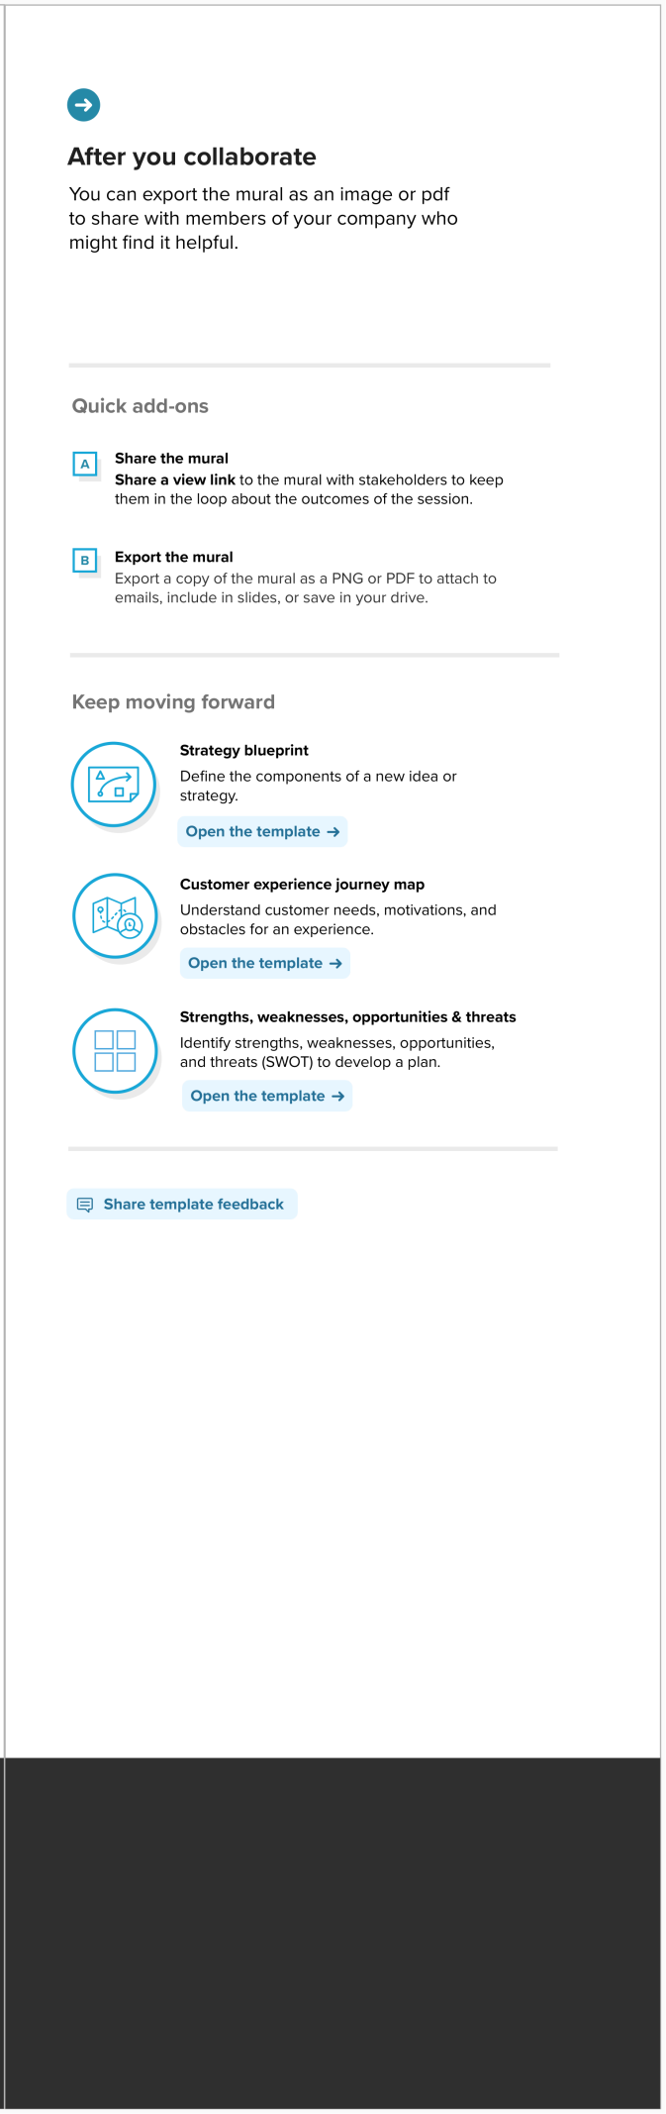

Mural Link : https://app.mural.co/invitation/mural/pnt2022tmid501175899/1666101091999?sender=uf7f9eea7c1d844daab415636&key=2c7030b0-d63c-4e9a-9501-96116a41daa7